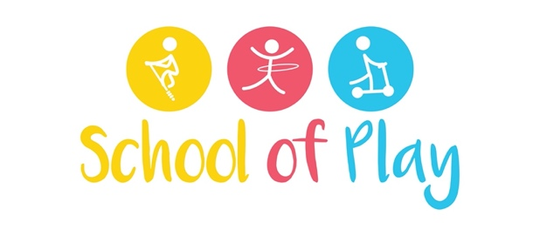

Newsletter (December 14th – 18th)

The Creepy Crawly Show

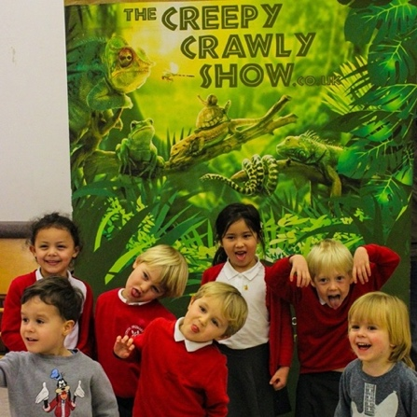
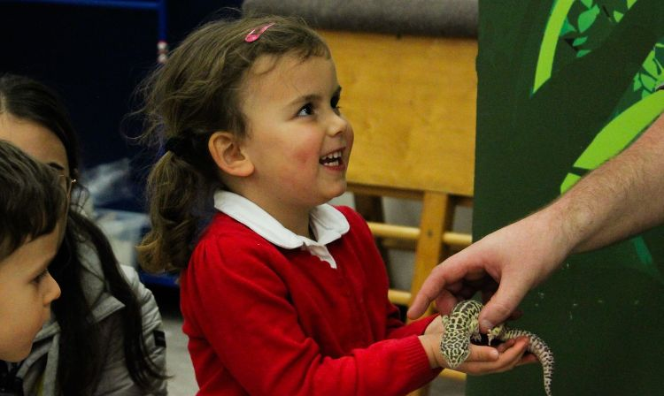

Last week, we hosted a spectacular Creepy Crawly Show! The children got the chance to meet a spider, a lizard, a cockroach, a hedgehog, a huge snake and a magnificent owl!
We believe it is important to organise events that differ from the children's day to day activities. Something unique, something intriguing. We want these kinds of events to create fantastic, long-lasting memories for every child involved.
The children loved meeting and greeting all the animals at this event, while also learning about their habitats and what cool things these animals can do. The staff we're particularly proud of the children's bravery when they held the gigantic snake!

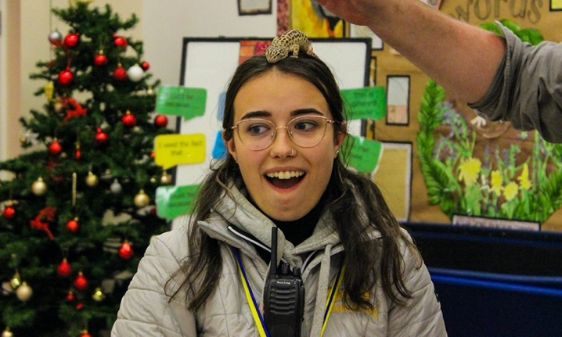

Upcoming Events

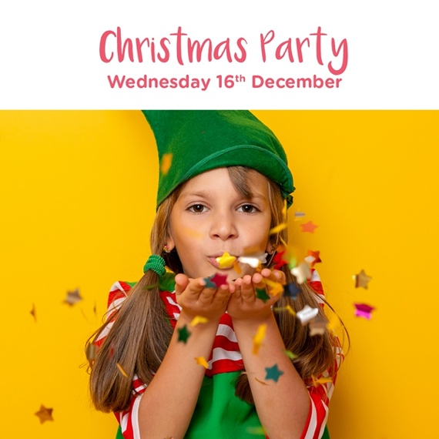

To secure your child's place for any of the events above, simply book an ad-hoc session for our wraparound care on the date required. If your child is already attending our after-school club, this will be included as part of your fees.

Pinata Birthdays!

Recently we have had a lot of School of Play birthday’s and we never fall short of a fun celebration at the club, especially when there's a sweetie filled Pinata on the cards!
Celebrating a birthday at either one of our breakfast or after school clubs not only builds excitement for the Birthday boy/girl, but it also sparks joy in every other child as well, creating the ideal environment for a little party celebration.
We always want the children to feel extra special on their birthdays and if you would like us to provide anything specific for your child's birthday, always feel free to ask!
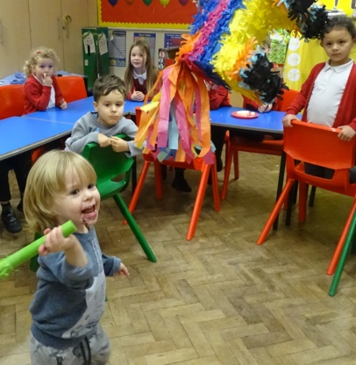
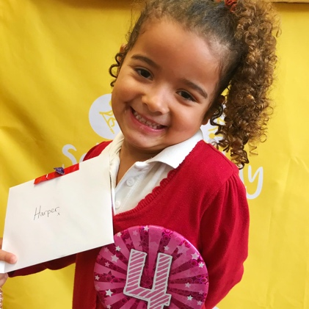

Handmade Christmas Cards

The club is flooded with Christmas Spirit this year and the children made some lovely, creative Christmas cards to add to our hampers for the food bank. Each card was designed beautifully by the children and we have read the most heart-warming message's that were written by the children. Spreading kindness in these uncertain times is extremely important and our club is filled with just that!
Have you started your Christmas cards yet?

